Management system of charities

# Goal and Description

This database aim to collect all possible information about the **Beneficiary**person that will get **Donations** from another **Donor** person, so it useful to determine the **Beneficiary** person that actually needs **Donations** based on the collected data about him.The charity manager will know all the following information:

* Donations that the charity has got.
* Determine the donation type and its quantity.
* Can easily connect to every person.
* History of each charity person.

The **MANAGEMENT SYSTEM OF CHARITIES** keeps track of **Beneficiary** persons, **Donor** persons and **Donations**.

Data requirements for the Management system of charities database are:-

1. We store each Person name, id, birth date, gender,Phone No,Address and his type (Beneficiary/Donor).
2. Each beneficiary person may be has a family member and income (or not).
3. Each family member has name, job, cost and gender.
4. Each Beneficiary person may suffer from some diseases(or not).
5. Each disease has type, medicine and its price.
6. Each Donor person donates by some donations.
7. Each donation has type (money/physical) and quantity or value.

Note: any unspecified requirements, can be specified from our EER diagram.

# EER-Diagram:

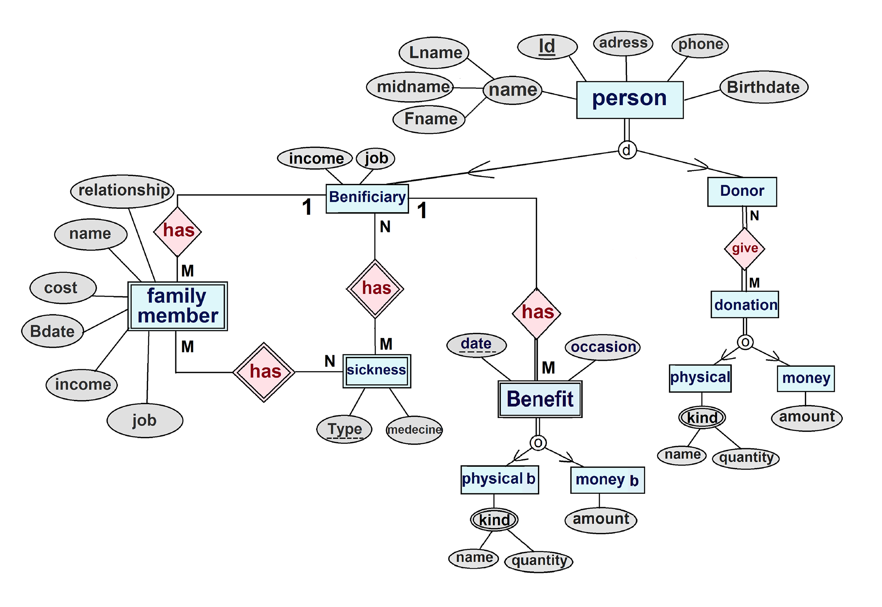

# RELATIONAL MODEL:

Donor person side

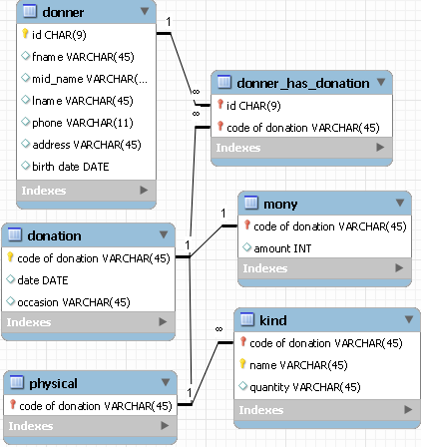

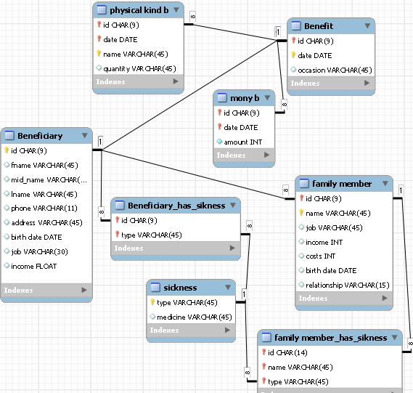

**Beneficiary person side**

* The following queries in SQL on the MANAGEMENT SYSTEM OF CHARITIES relational database

1. RetrieveNumber of Beneficiaries and Number of Donors.

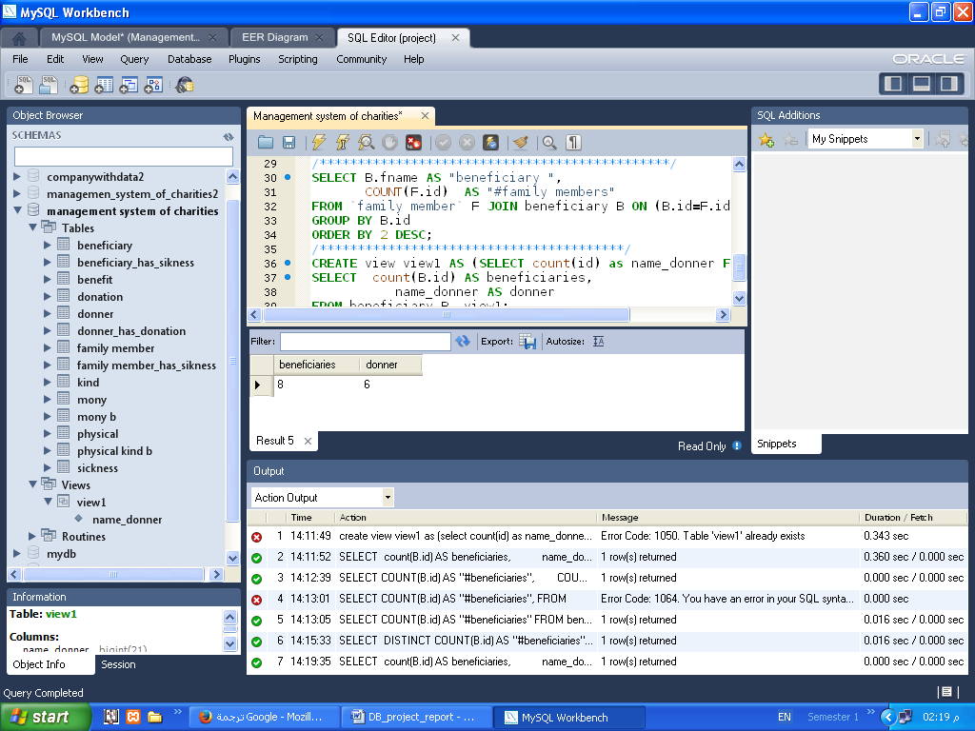CREATE view view1 AS (SELECT count(id) as name_donner FROM donner);

SELECT count (B.id) AS beneficiaries,

name_donner AS donner

FROM beneficiary B, view1;

1. RetrieveContact information for beneficiaries who have income less than 1000 LE.

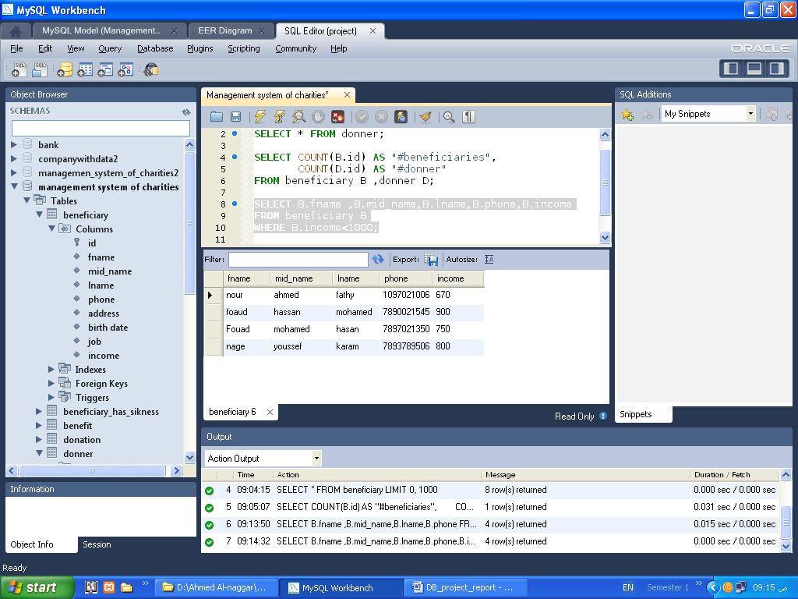SELECT B.fname, B.mid_name, B.lname, B.phone, B.income

FROM beneficiary B

WHERE B.income<1000;

1. 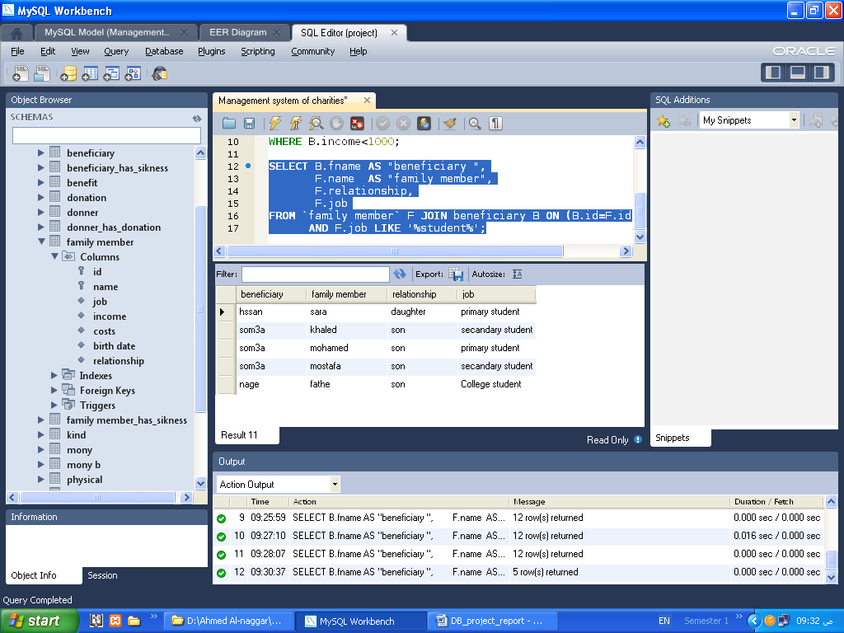Retrieve every beneficiary has family members who learn.

SELECT B.fname AS "beneficiary ",

F.name AS "family member",

F.relationship,

F.job

FROM `family member` F JOIN beneficiary B ON (B.id=F.id)

AND F.job LIKE '%student%';

1. 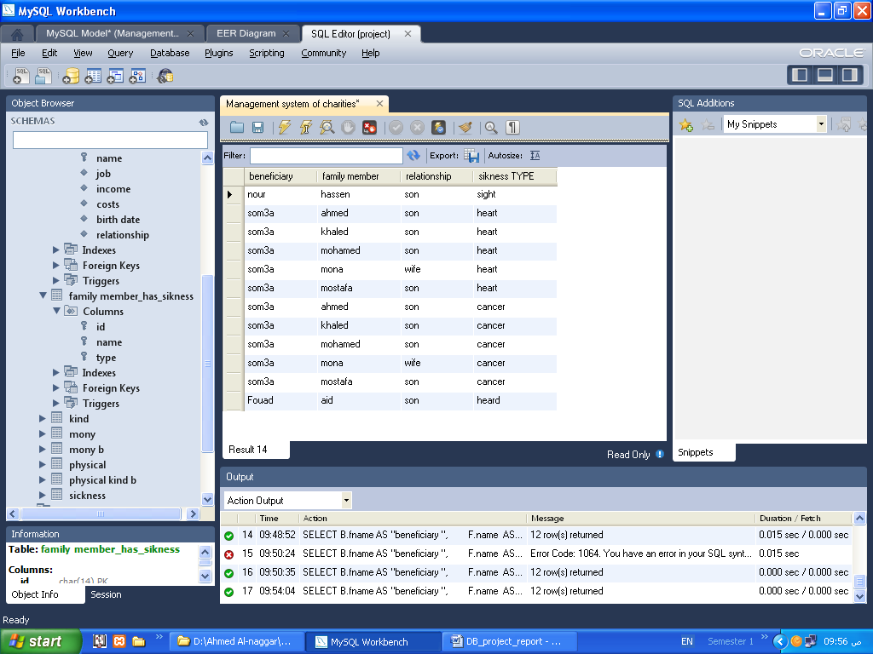Retrieveevery person is a beneficiary and the diseases suffered by members of his family.

SELECT B.fname AS "beneficiary ",

F.name AS "family member",

F.relationship,

FS.type AS "sikness TYPE"

FROM `family member` F LEFT OUTER JOIN beneficiary B

ON (B.id=F.id),

`familymember_has_sikness` FS

WHERE FS.id = F.id; 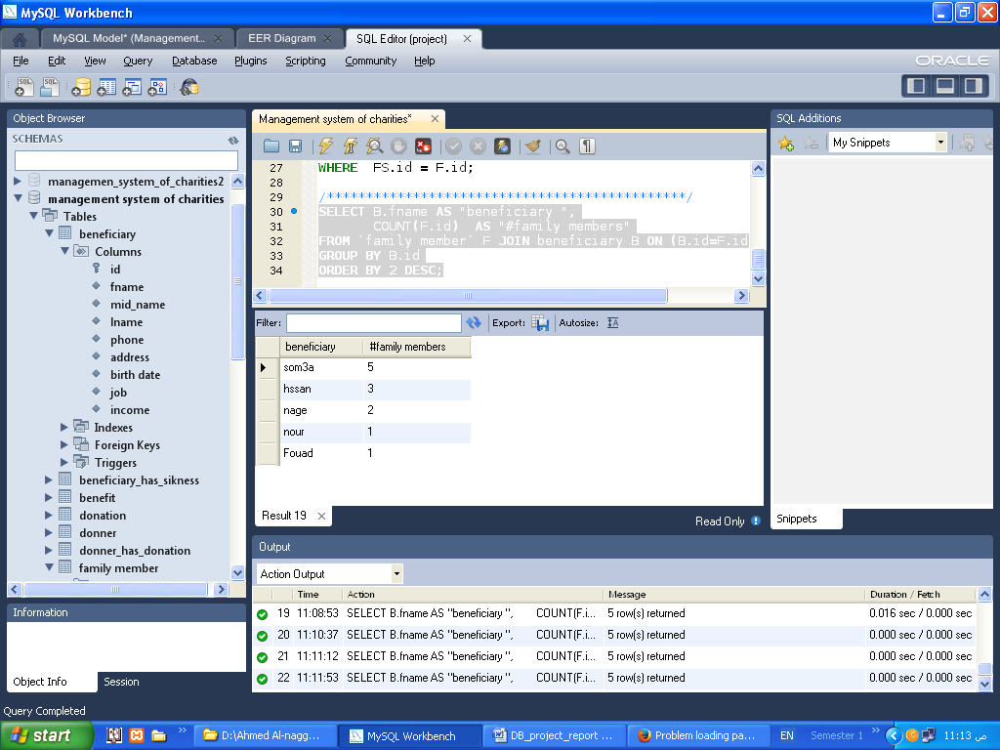

1. RetrieveNumber of family members per beneficiary.

SELECT B.fname AS "beneficiary ",

COUNT (F.id) AS "#family members"

FROM `family member` F LEFT OUTER JOIN beneficiary B ON (B.id=F.id)

GROUP BY B.id

ORDER BY 2 DESC;

1. 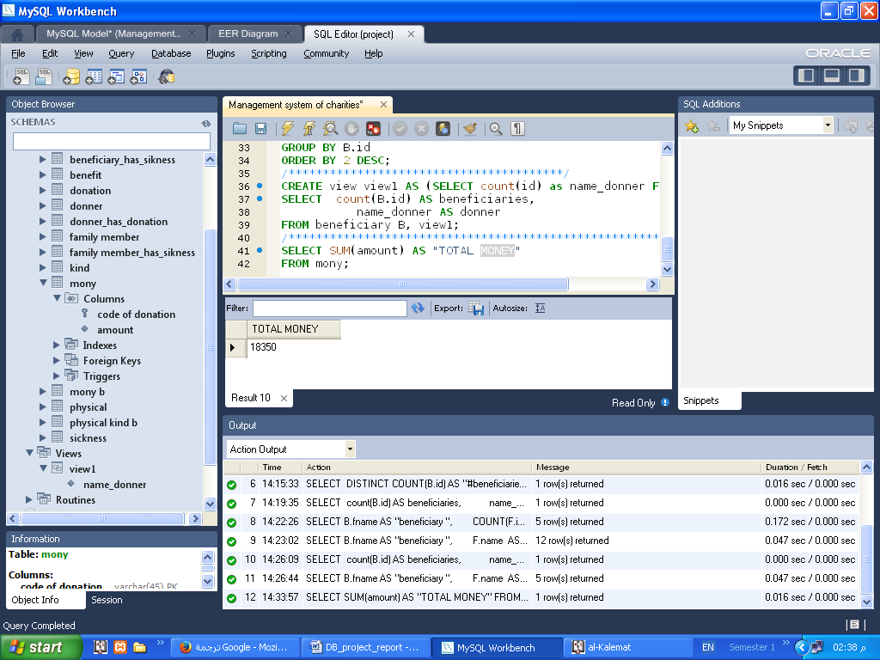RetrieveThe total amount of money owned by the association as a result of donations.

SELECT SUM (amount) AS "TOTAL MONEY"

FROM mony;

1. 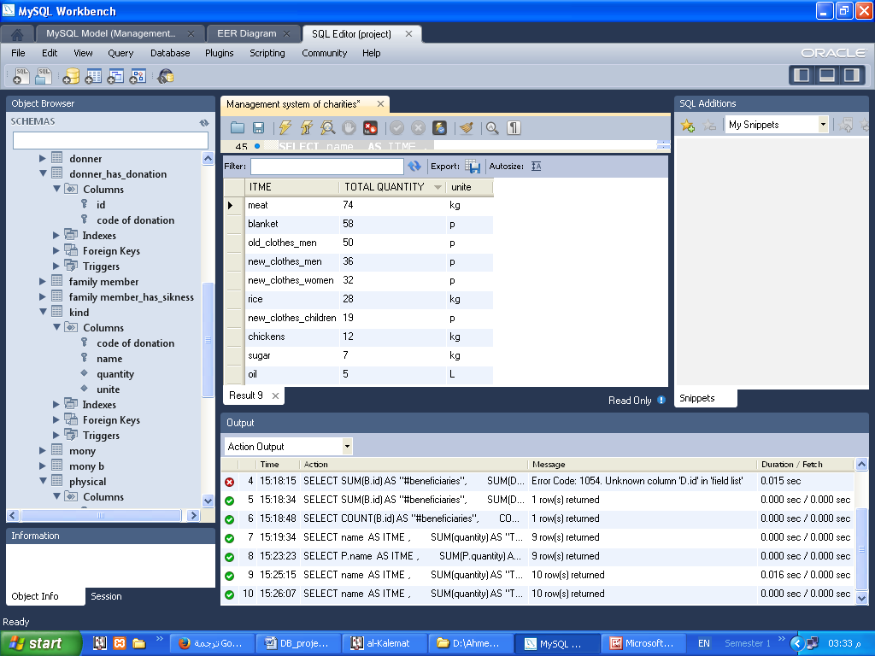RetrieveAmounts available from each physical donation.

~~ملحوظة:تم تعديل Quantity Column وتقسيمة إلى 2 unite and Quantity~~

SELECT name AS ITME,

SUM (quantity) AS "TOTAL QUANTITY", unite

FROM `kind`

GROUP BY 1;

1. Retrieve   
     
   name of the parent and its job and name of the family member   
   and its job and the relation to the

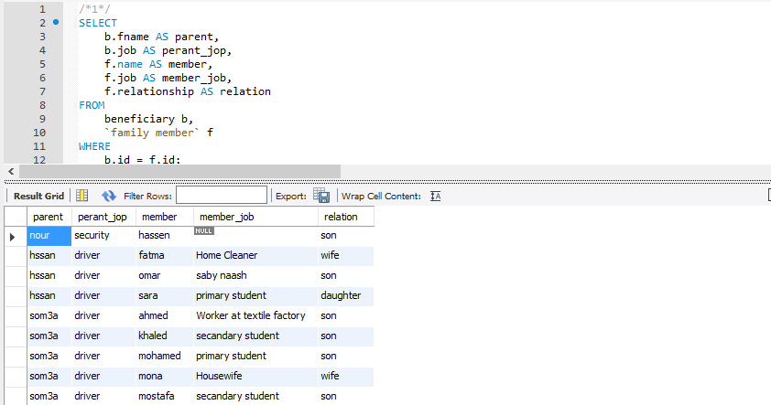

9)Retrieve  
  
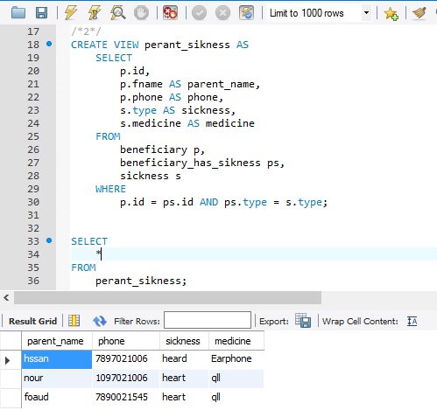  
all the perant that have illness

1. Retrieve   
   all the family member that have illness  
   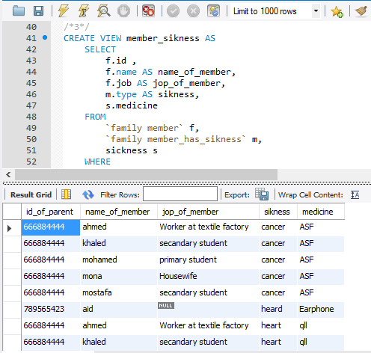
2. Retrieve   
   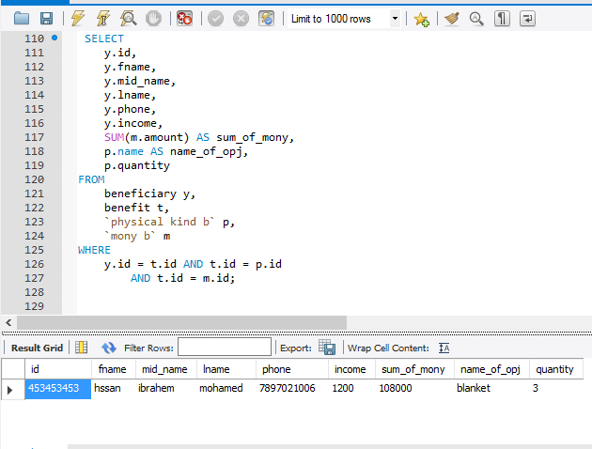  
   select all the person that got amony and physical things   
   and the amount of the mony and the amount of the physical things
3. Retrieve   
   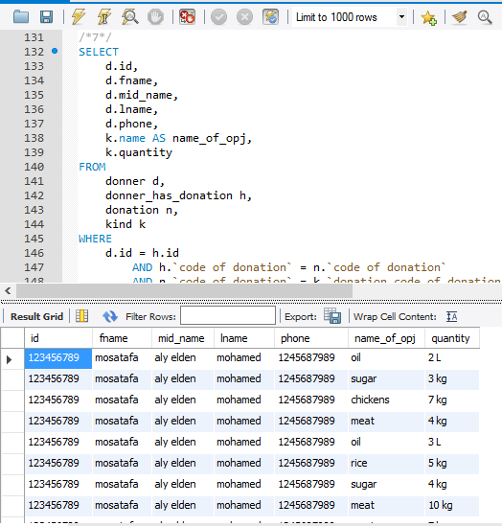  
   select all the person that got aphysical things only   
   and the amount and kind of this things

***12)Retrieve Total amount of money obtained on each occasion***

select n.occasion,sum(m.amount)as TheSumOfAmountgetfromdonner

from donation n,mony m

wheren.`code of donation` =m.`code of donation`

group by n.occasion;

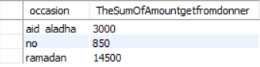

***13)Retrieve The Name of beneficiary and income ,jop and occasion and the Data***

***And name of physical and quantity The beneficiary get***

***select b.fname as beneficiaryname ,b.income, b.job as beneficiaryjop , ben.occasion, ben.date,p.name,mb.amount,p.quantity***

***from beneficiary b,benefit ben, `mony b` mb,`physical kind b` p***

***where b.id=ben.id and ben.id=mb.id and ben.id= p.id ;***

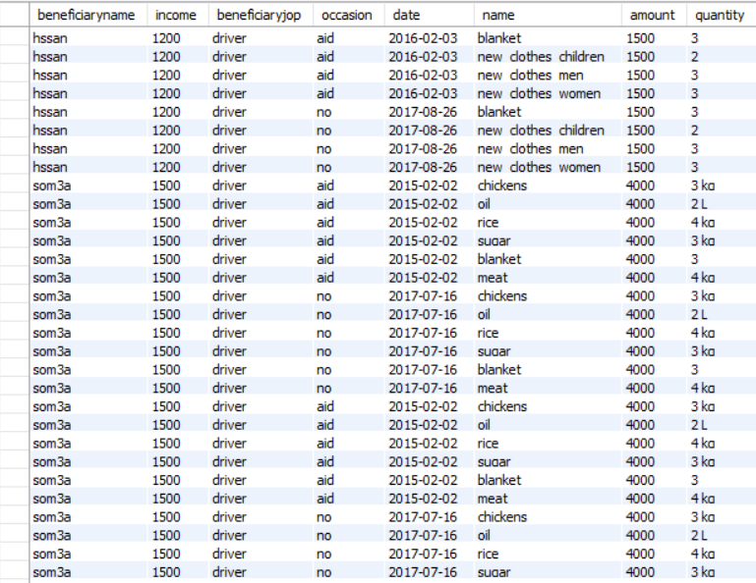

***14)Retrieve the Name beneficiary and thefamilyname,***

***Familyjob ,income ,costs, relationship, familybirthdate***

***selectb.fname as beneficiaryname,f.name as familyname,f.job as familyjob,f.income,f.costs,f.relationship,f.`birthdate`asfamilybirthdate***

***from beneficiary b, `family member` f***

***where b.id=f.id;***

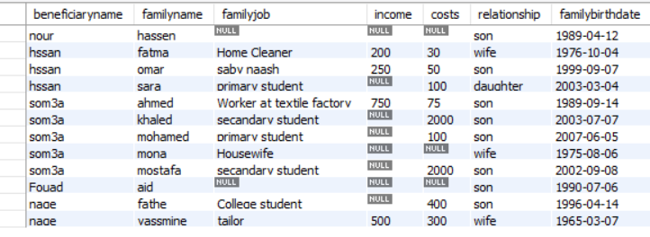

***15)Retrieve The beneficiary name and income , beneficiary job***

***Type and treatment of disease***

***select b.fname as beneficiaryname,b.income,b.job as beneficiaryjob,s.type as typeofdisease***

***,s.medicine as treatment of disease***

***from beneficiary b,sicknesss,beneficiary_has_siknessbs***

***where b.id=bs.id and bs.type=s.type ;***

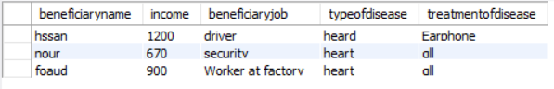

***16)Retrieve The beneficiary name and income , beneficiary job***

***But Not suffering from any disease***

***selectb.fname as beneficiarynameISNot suffering from any disease***

***from beneficiary b***

***where (b.id) not in (select b.fname***

***from beneficiary b,sicknesss,beneficiary_has_siknessbs***

***where b.id=bs.id and bs.type=s.type);***

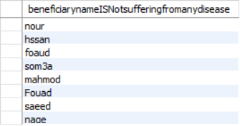

***17)RetrieveBeneficiary name and family name***

***And job, income, costs, relationship of family Type and treatment of disease***

***selectb.fname as Beneficiary name,f.name as familyname,f.job as familyjob,f.income,f.costs,f.relationship,s.type ,s.medicine as treatment of disease***

***from beneficiary b,`family member` f, sickness s,`familymember_has_sikness` fs***

***where b.id=f.id and f.id=fs.id and f.name=fs.name and fs.type=s.type;***

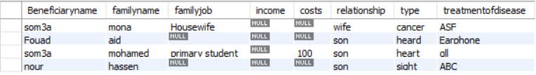

***18)Retrieve Beneficiary name and family name and***

***job, income, costs, relationship of family But Not suffering from any disease***

***selectb.fname as beneficiaryname, f.relationship,f.name as familynameISNot suffering from any disease***

***from `family member` f, beneficiary b***

***where b.id=f.id and (f.name) NOT IN (***

***select f.name as familyname***

***from `family member` f, sickness s,`familymember_has_sikness` fs***

***where f.id=fs.id and f.name=fs.name and fs.type=s.type);***

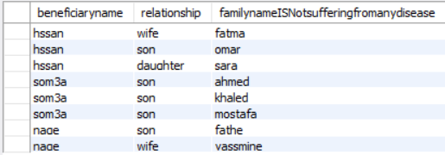

***19)retrieve***The sum of the quantities that the donor receives for each name of the type of objects and the sum of the quantities given to the beneficiary for each name

***select k.name as kindName, sum(k.quantity)as theSumofamountGetFromdonner,kb.name,sum(kb.quantity)as theSumOfAmountGivetobeneficiary***

***from kind k ,`physical kind b` kb***

***group by k.name;***

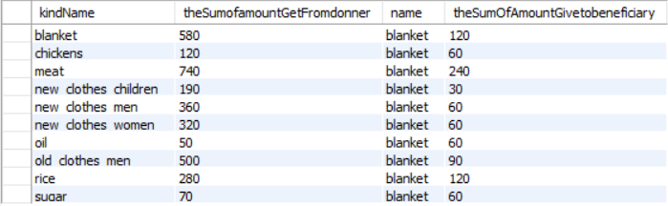

***20) Retrieve***The name of the beneficiary, the sum of the quantities and the name of the quantity type for each quantity and the sum of the money to the beneficiary

***selectb.fname as beneficiaryname,p.name,sum(p.quantity) as TheSumOfQuantityToEveryBinficiary,sum(mb.amount)as TheSumOfAmountToEveryBinficiary***

***from beneficiary b,benefit ben, `mony b` mb,`physical kind b` p***

***where b.id=ben.id and ben.id=mb.id and ben.id= p.id***

***group by p.name;***

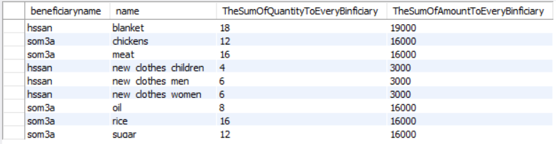

***21) Retrieve The donor's name,mid name, last name, address, date, occasionand amount of money to donate to her but donate money***

***select d. fname,d.mid_name,d.lname,d.address,n.occasion,n. date,m. amount***

***fromdonner d, donner_has_donation o , donation n ,mony m***

***where d.id=o.id and o. `code of donation`=n.`code of donation` and n.`code of donation`= m.`code of donation` ;***

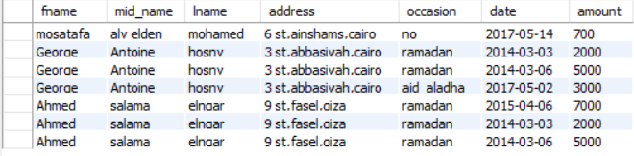

***22) The name of the donor, the address, the date, the appropriate date, the quantity of the name, the type of quantity, and the quantity to be donated***

***select d. fname,d.mid_name,d.lname,d.address,n.occasion,n. date, k.name as nameKind,k.quantity***

***fromdonner d, donner_has_donation o , donation n , physical p, kind k***

***where d.id=o.id and o. `code of donation`=n.`code of donation` and n.`code of donation`= p.`code of donation` and k.`code of donation`= p.`code of donation` ;***

